Data types can be categorized into two types
- Primitive
- Non-Primitive
Primitive and non-primitive can be further be categorized into three types
- Local
- Static
- Non-Static

Local Variables or local datatypes
Variables which are declared within a method or constructor or blocks such variables are called as local variables.
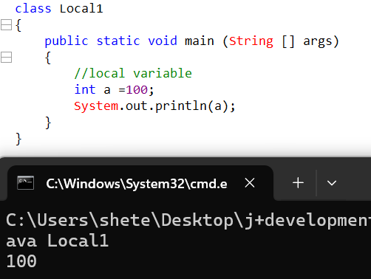
IMP note: We can access local variables directly
Is it possible to print local variable without initializing?
Ans: it is not possible
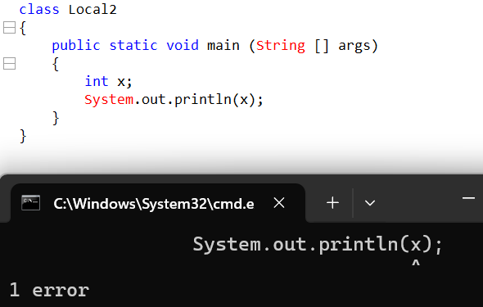
It is possible in java to just declare variable without initializing.
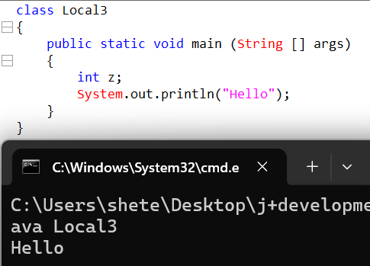

Static Variable
Variables which are declared outside the method or constructor or block but within the class and is prefix with static keyword such keyword called as static variables.

How do we access static keyword?
Ans: . operator or access operator to access a member within a specific area we use . operator or also called as access operator

How many ways are there to access to static variables?
Ans: There are three approaches
- Directly
- Class Name
- Object
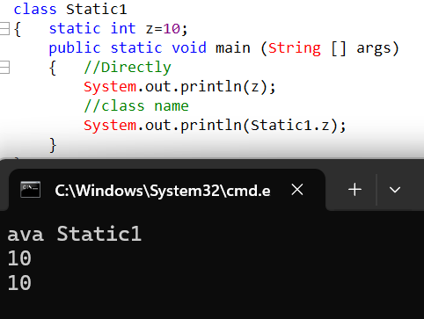

Write a java program to add two static variables?
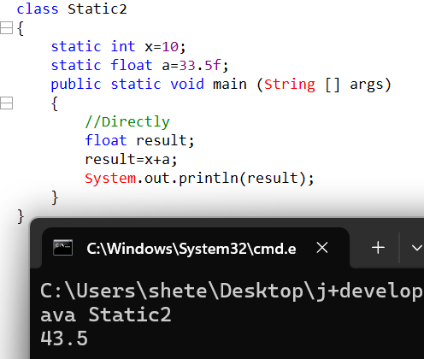

IMP note: we cannot use static keyword for local variables.
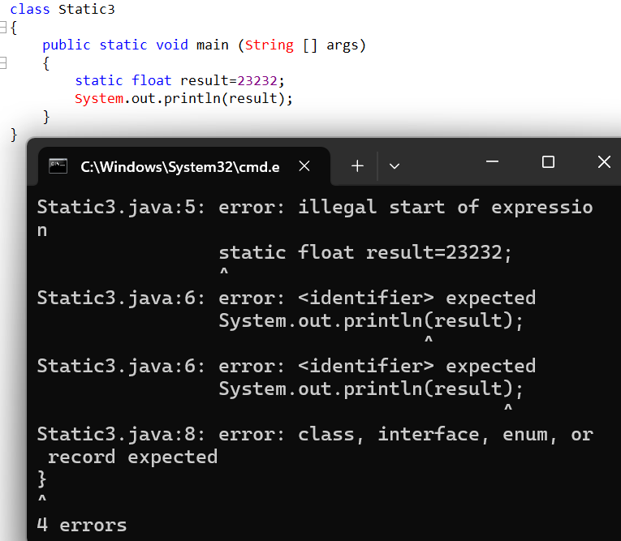

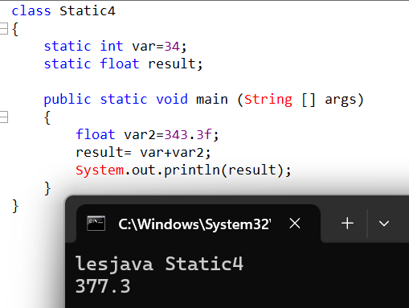

How many ways are there to access static variables from another class?
- Class name
- Object
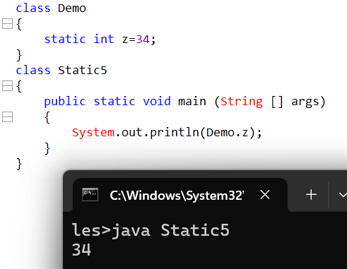
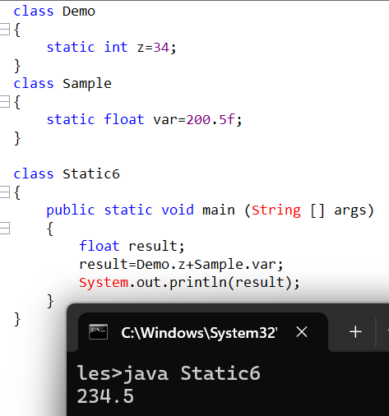
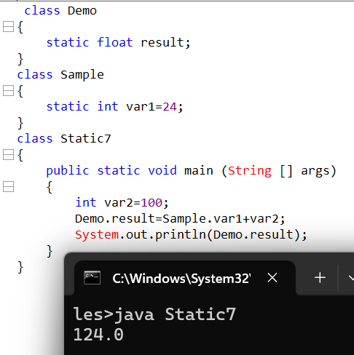
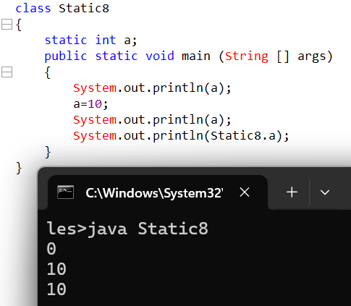

Methods
Methods in java can be categorized into two types
1.static 2. Non-static
Method can be defined as block of code which are meant to perform specific operation.
What is benefit of using Method.
The benefit of using methods are:
- It will help to reduce or avoid duplicate code.
- It will help reduce the code length
- It will help consume user memory.
- It will consume less time for execution.
- The application speed will be faster.
Syntax:
[Access modifier] [modifier] return type method name (variables arguments)
{
Statement;
Return
}
1.Return statement is used to return the control back to the caller method.
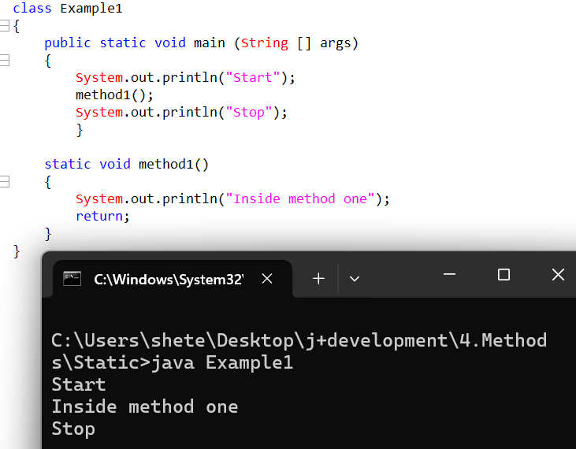
2.If we do not use return statement the control will be lost and other statement will not get executed.
If we do not use return statement then the compiler will set the return statement by default.
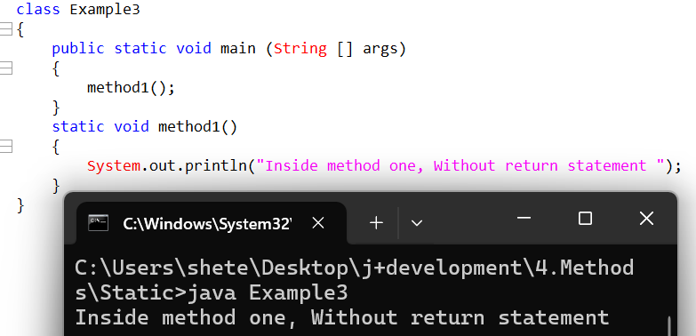

3.The return statement always should be used at end of method.
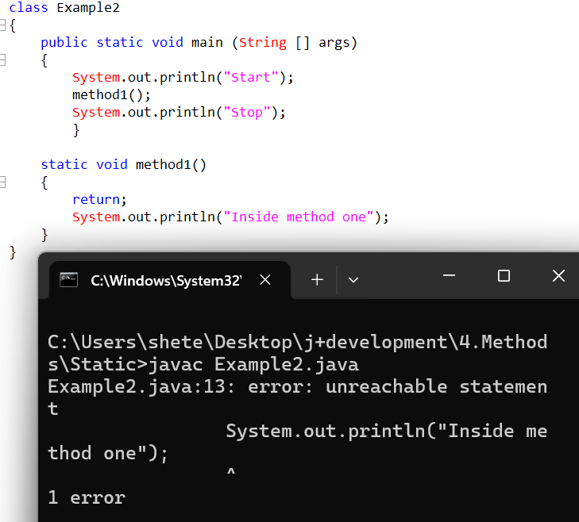

4.When should we go for pass by value
Whenever we want to access local variables, we go for pass by value.
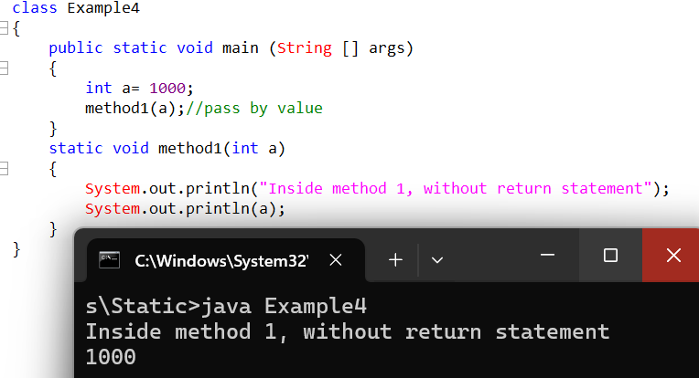

Q1. Write a java program to display the area of triangle
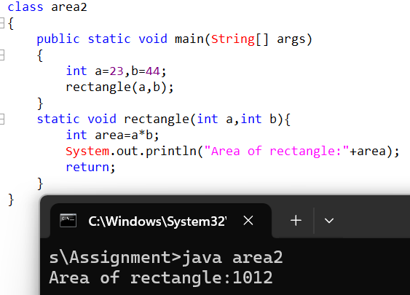

Q2. Write a java program to calculate area of circle.
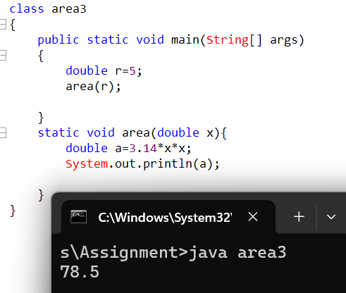
Q3. Write a java program to find area of rectangle.
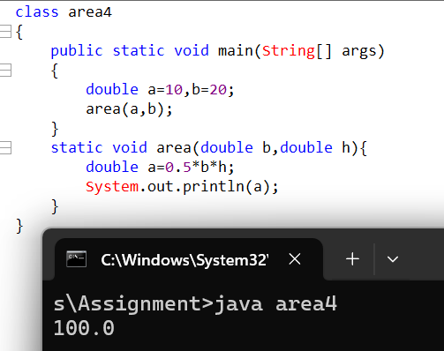

5.If a method is associated with the void keyword when the method has to only return a control and nothing else.
6.Depending on the data to be returned the method return type should be of same type.
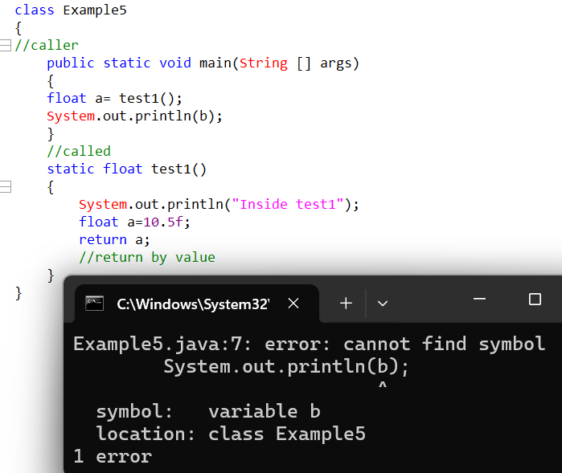
7.When we should go for return by value?
- Whenever we are moving control from caller method to called method we have to go for pass by value.
- Whenever we have to move the control from called method to caller value we have to go for return by value.
- Whenever we have to pass multiple values to the method a method can accept multiple values.
- Hence in pass by value we can pass multiple values.
- But whenever a method has to return a value, it can return only one value at any point of time.
- A method can return only one value because a method will have only one value.
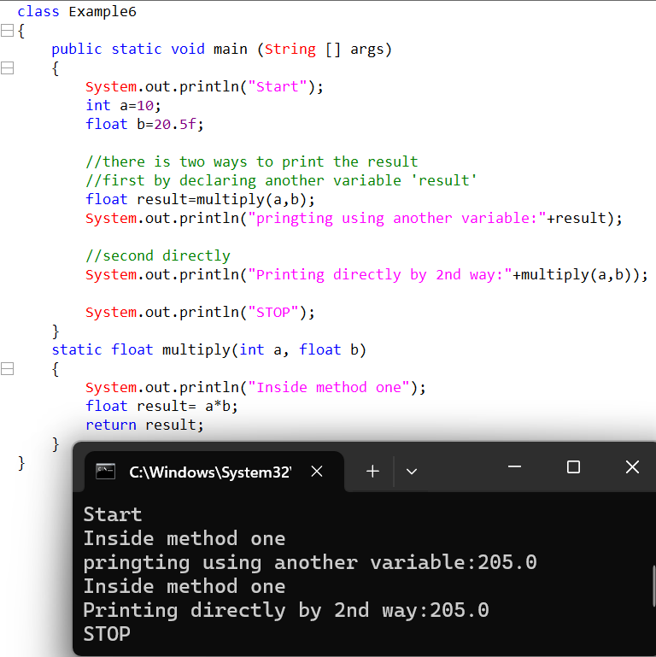
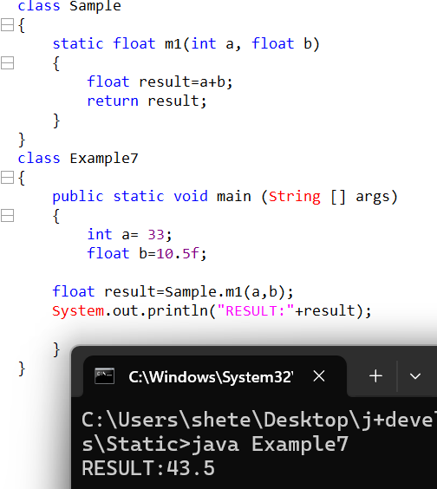
Variables which are declared with in main or part of method or constructors or blocks, such variables are called as local variables.
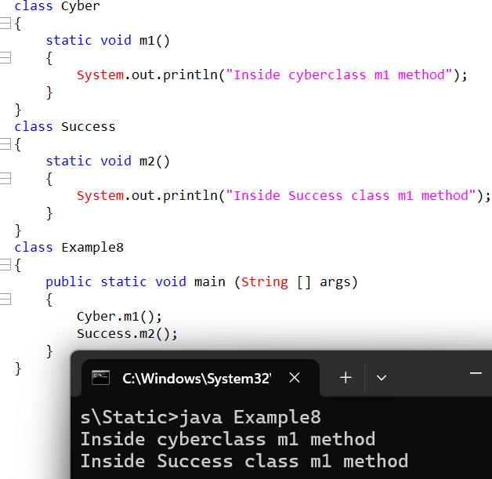
Whenever JVM is called for execution, it will always and always consume RAM memory.
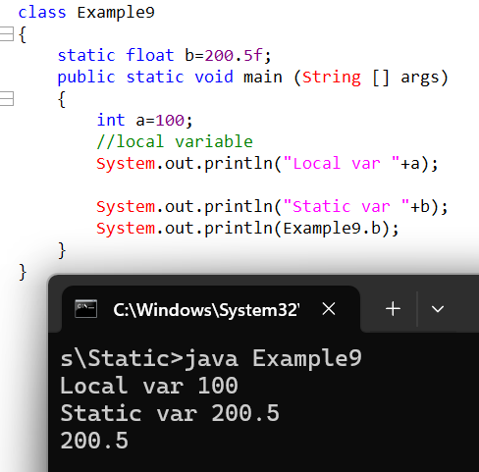
- Static members are always loaded within the static pool.
- Static members are loaded at class loading time.
- Main and any other methods are always executed in static area.
- Local variables are always created in stack area.
- Whenever a method look for variable the preference is always given to stack area.
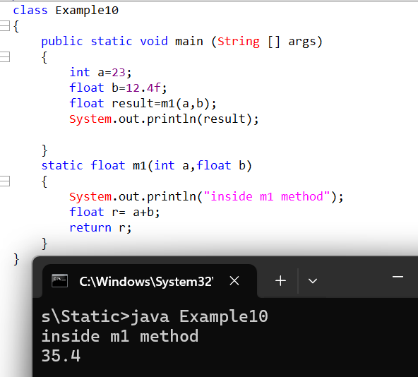
Why Is the main method named as static?
Whenever JVM enters the stack the first thing what the JVM does it will go to the static pool and look for main if the main is present then it will start the execution if the main is not present then execution can’t be started.
If a static variable is declared outside the method but initialize within a method such variables will still be considered as static variable. 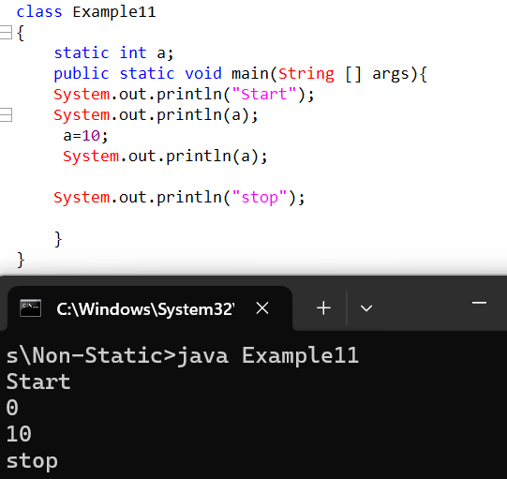

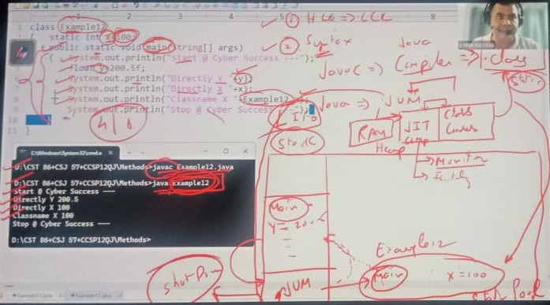

- Whenener JVM comes for execution, The First thing it performs is it splits the RAM into two parts one is Stack and One is Heap after splitting.
- After splitting the controller is given to Class loader along with other components like JIT (Just in Time Compiler). The other components including JIT and class loaders are part of the JVM.
- The Class loaders are responsible to load the static members within the static pool during the class loading the JIT compiler will not only monitor but will also initialize during this particular period.
- The Static members whenever loaded is called as static pool as is given the same name as class name.
- Once loading happens JVM control enters the stack area, the first thing what JVM finds is main if the main is present it will start the execution if not present it will not start the execution the main method for execution will be loaded within the stack.
- When the method is loaded within the stack it will create local variables within stack area.
- The Stack always follows LIFO (Last in First Out) passion.
- Once the main method performs the operation the controller will be given back to JVM and the main method comes out of stack area by giving controller to JVM and based on execution JVM will shut down by coming out of stack area.

Non-static variables and methods
Variable declared outside the method, constructor and block but within the class and it is not prefix with the static keywords such variables are called as non-static variables.
How do we access non static members
We can access non static members with the help of object creation.
Syntax for object creation.
Classname variable = new classname();
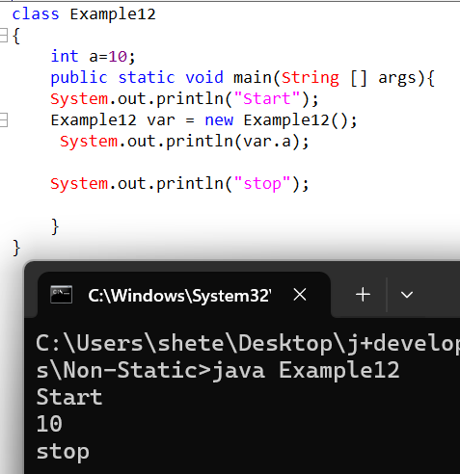
New
New is keyword
What exactly is role of new in object creation.
The new keyword is meant to perform three actions.
- It is made to create or allocated memory
- It is responsible to load non static members(methods,variables).
- It is made to help generate an address along with JVM.
- Whenever an address of an object will generate it will be stored in a variable.
- If objects are created based on classes which means to create an object it is mandatory we required a class.
How many times will the object get created within program
Based on total no of new keywords as many times object will created
- Whenever there are changes made to one object it will never have an impact on another object because both object areas are different.
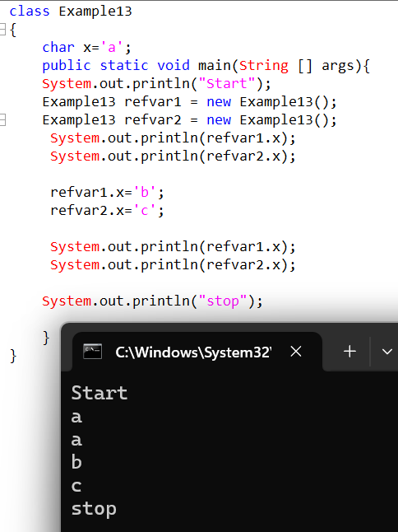

A single object creation will be responsible to load all not static members of a respective class within the object
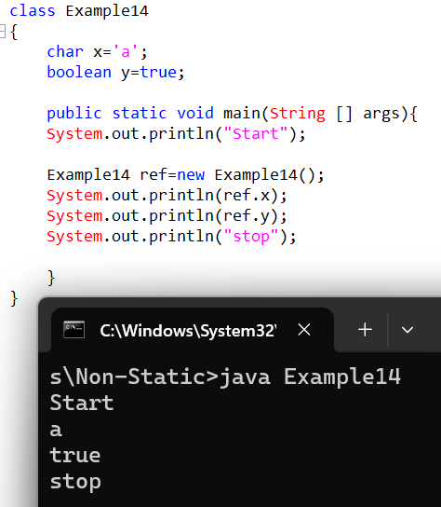
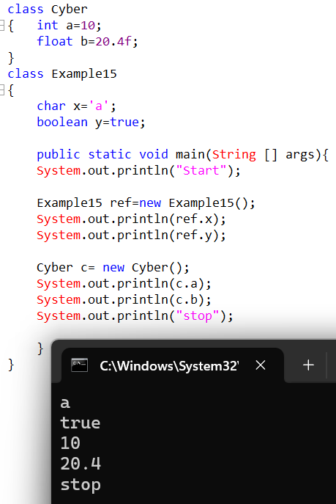

If a method is not prefix with keyword static then the static method becomes non-static.
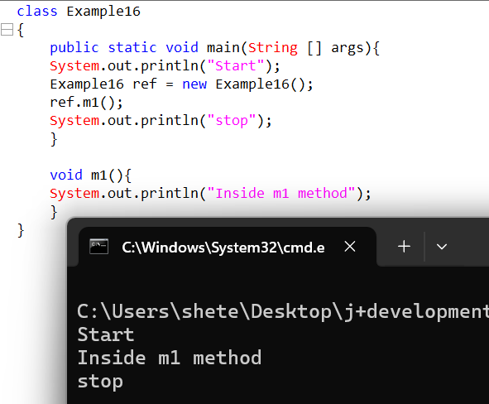
To access any local variable from static to non-static method or from non-static to static method we use pass by values or return by value.
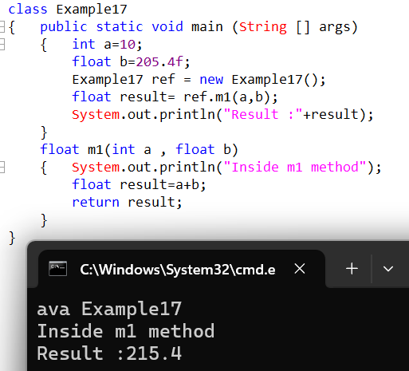

///quadrant diagram

To be accessed | 1 | 2 | 3 | 4

Members | Static | Static | Non static | Non static
Area | Static | Static | Static | Static
class | Single | Multiple | Single | Multiple

To be accessed | 5 | 6 | 7 | 8
Members | Static | Static | Non static | Non static
Area | Non Static | Non static | Non Static | Non Static
class | Single | Multiple | Single | Multiple

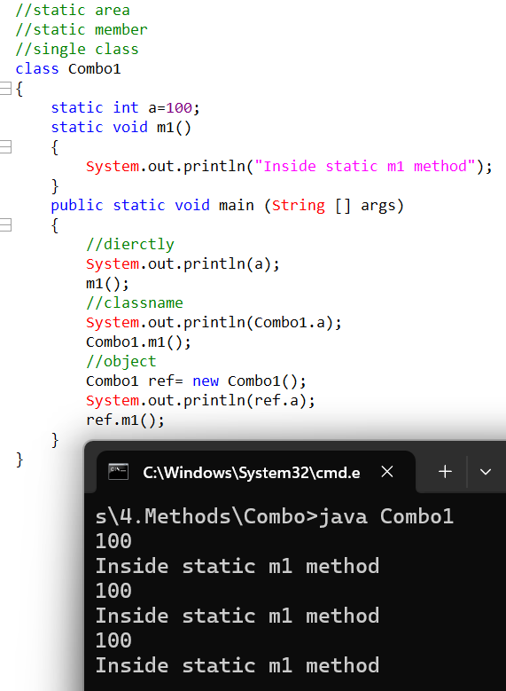
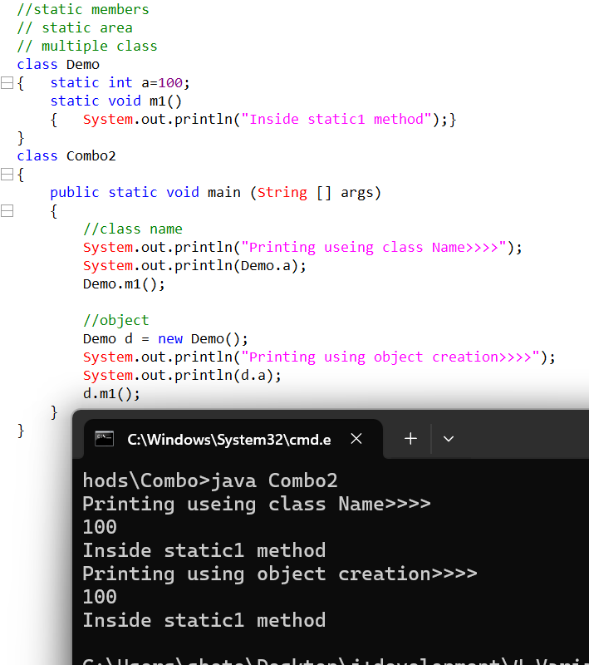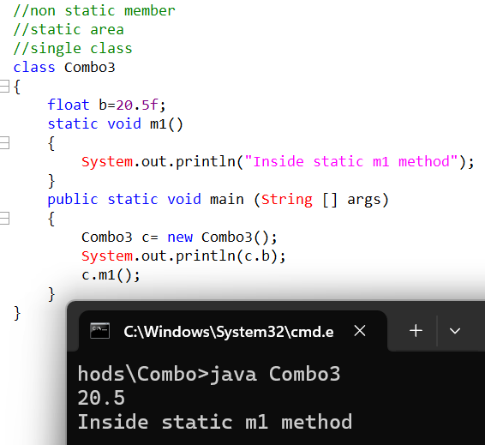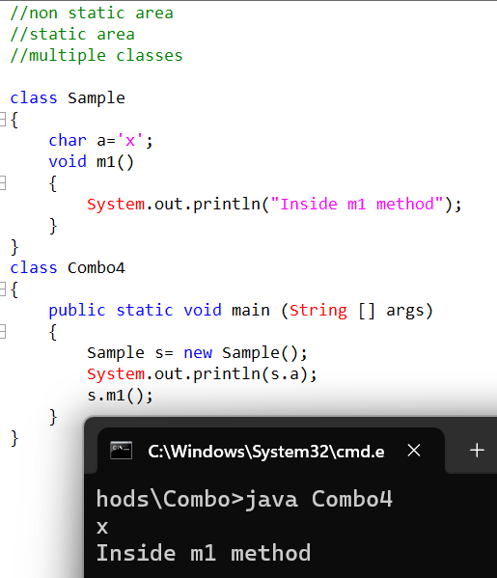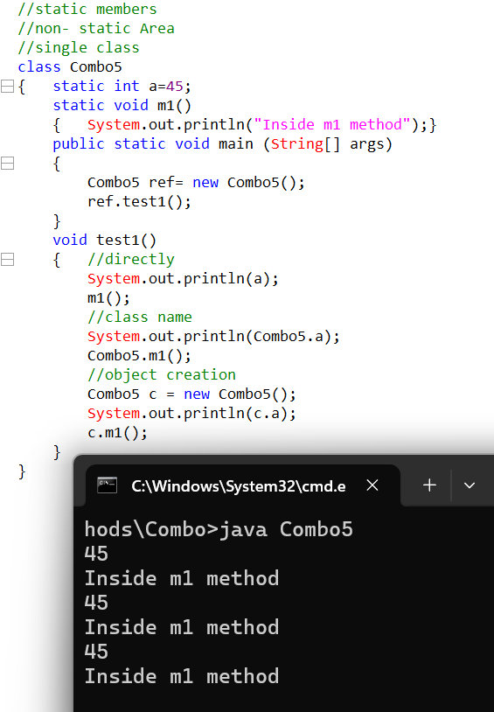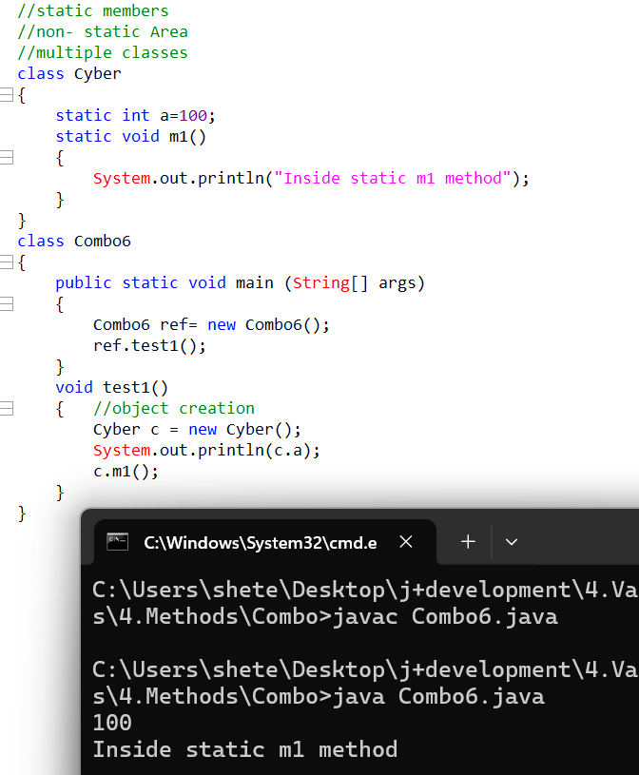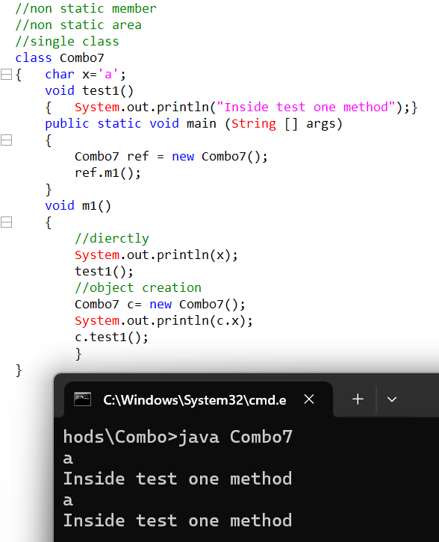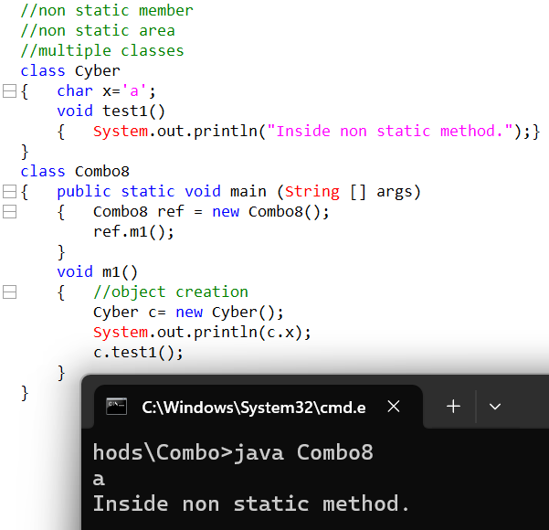

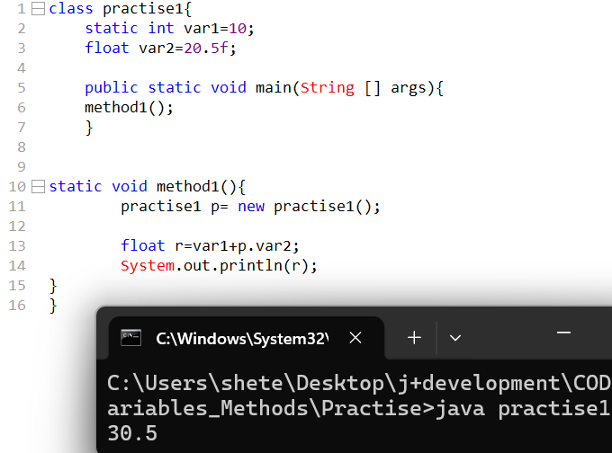
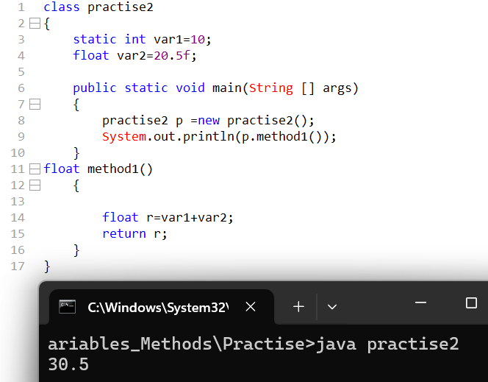
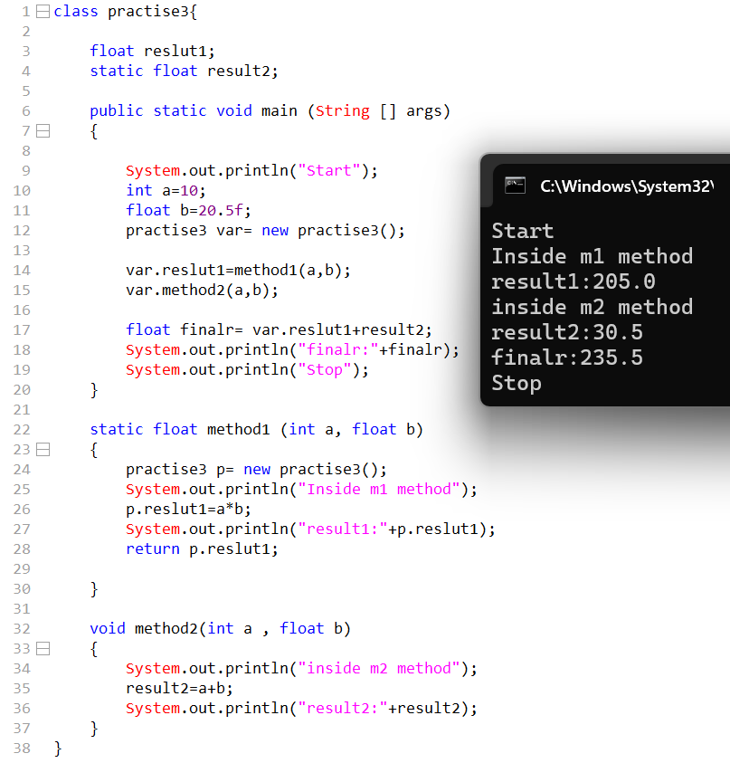

//3,4

Non-Primitive or Reference Type
- Primitive data types are meant to store data which can be in different data formats.
- Non primitive variables will also store address but these addresses belongs to different classes.
- Non Primitive variables are also called as class type variables.
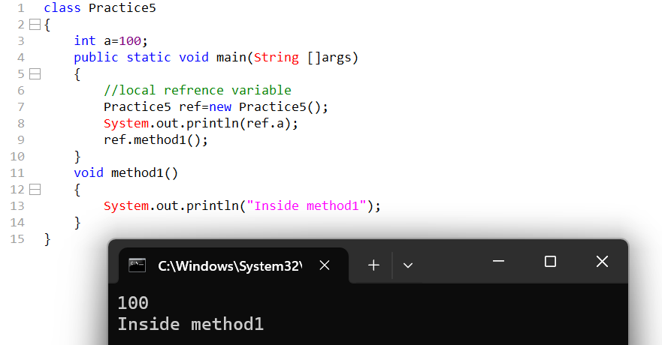

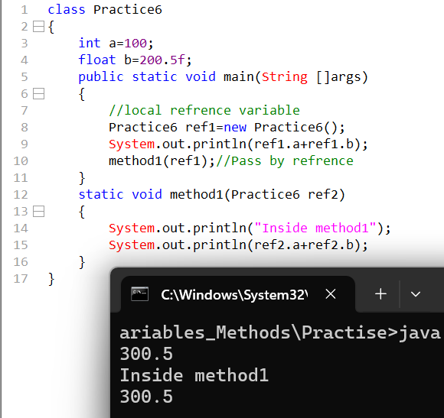
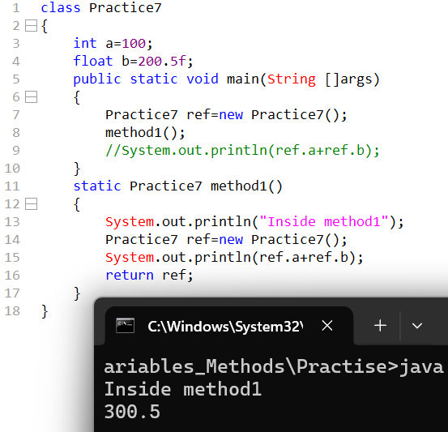
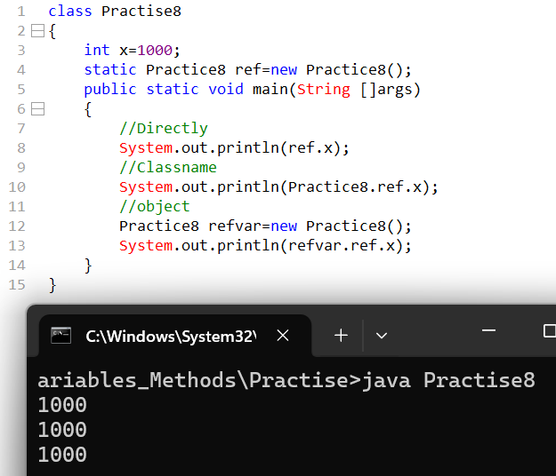
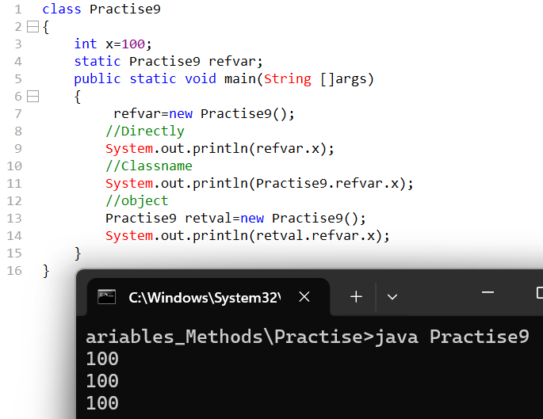
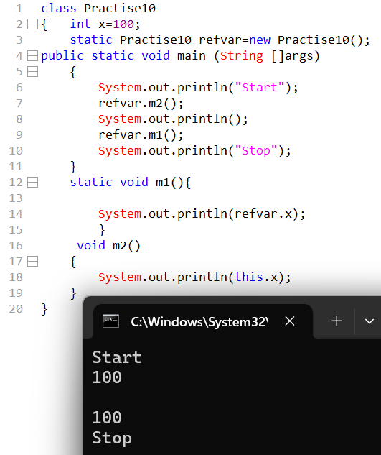
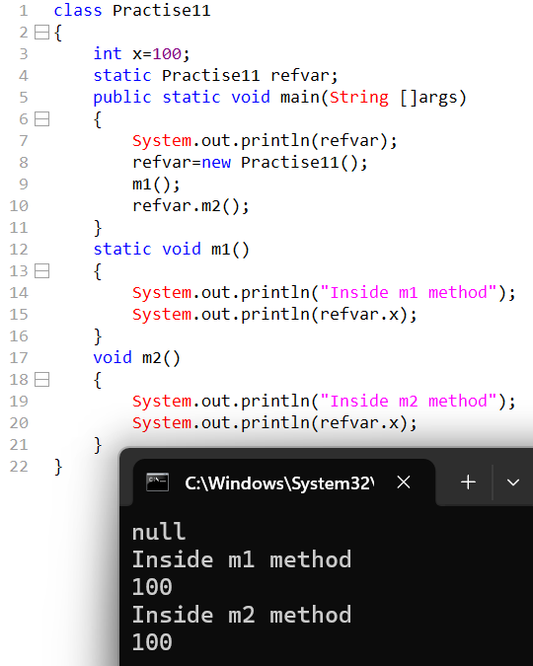
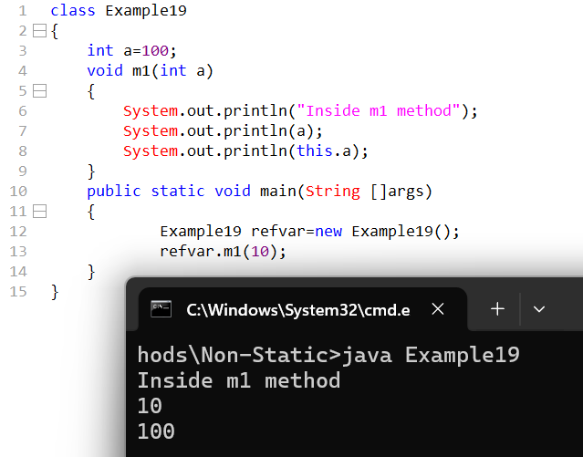
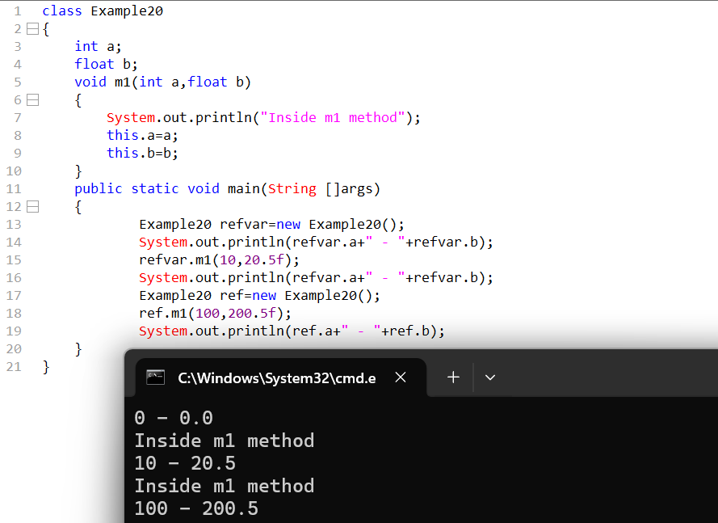
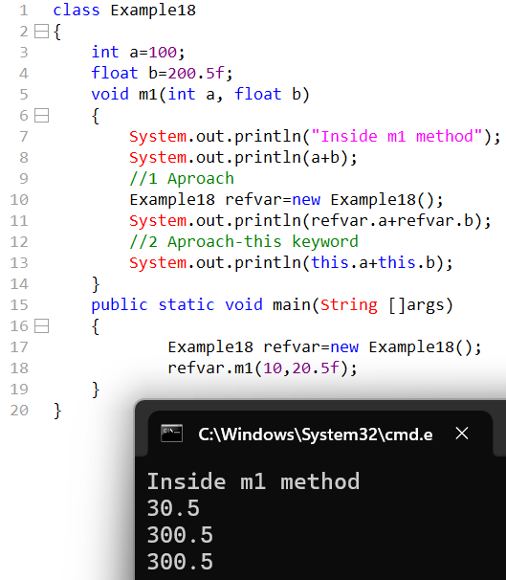
When to use this keyword
To differentiate between local and instance variables / non static variables when the variable names are same then we use this keyword.
//example21
22
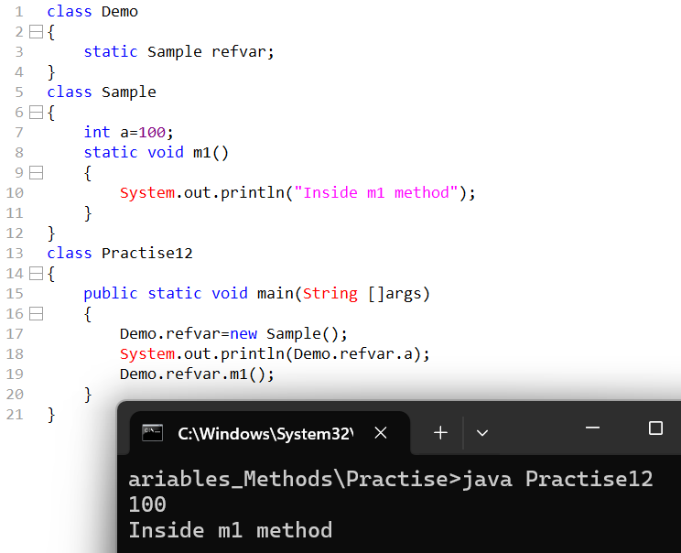
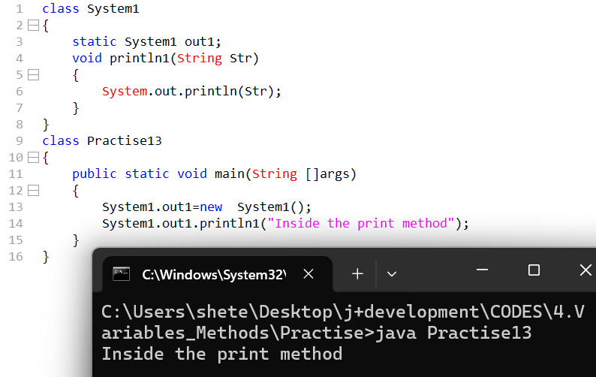
//example23-25
There are two ways to create an object
- Name the object creation
- Name + object creation
From a non-static context, we can access both static and non-static members.
But from a static context we can access only static members.
28
When to make members static?
Whenever the data or service which is common in such a situation we make the members static.
Whenever the data and service are unique, we make the member as non-static.
//cybersuccess

  - IMP QUESTIONS
- What are the local variable?
Variables which are declared within a method or constructor or blocks such variables are called as local variables.

- Is it possible to print local variable without initializing? Why?
No, Local variables must be explicitly initialized because they are stored in the stack and Java does not assign them default values.

- What are the static variables?
Variables which are declared outside the method or constructor or block but within the class and is prefix with static keyword such keyword called as static variables.

- How can we directly access static members?
Static members are loaded by the JVM’s ClassLoader at the time of class loading, before any object of the class is created. The ClassLoader loads the class into memory, and during the class initialization phase, all static variables and static blocks are executed once.

- Why we can't use static keyword for local variables?
We cannot use the static keyword for local variables because static members belong to the class, whereas local variables belong to a method or block and exist only during method execution.
- static requires class-level storage
- Local variables do not exist at class loading time
- JVM cannot associate a local variable with the class

- What are methods? Example
Methods are blocks of code defined inside a class that perform a specific task.
Example: If my class is car then clutch(), brake(), acceletor() are my methods.

- When should we go for pass by value?
When we have to access local variables inside the methods or constructors also We go for pass by value when we want to protect the original data from being modified. In pass by value, a copy of the variable is passed to the method, so changes made inside the method do not affect the original variable

- What is void?
void is a return type in Java that indicates a method does not return any value. It is used when a method only performs an action and does not need to send data back to the caller.

- What type of memory does jvm consume why?
JVM consumes RAM (main memory) because Java programs are executed at runtime.

- Why is the main method named as static?
Whenever JVM enters the stack the first thing what the JVM does it will go to the static pool and look for main if the main is present then it will start the execution if the main is not present then execution can’t be started.

- What are the non-static variables?
- Non-Static variables are the variables which are declared inside class and outside the methods, constructor and blocks.
- They are instance variables that belong to an object, not to the class. Each object gets its own separate copy, and they are accessed using an object reference.

- Is it possible to print static and non-static variables without initializing?
Yes

- Who assigns default values for static and non-static variables;
- Static variables: JVM(Just-in-Time compiler) initializes while class loading
- Non-Static variables: JVM initialize while object creation.

- What is the role of new in object creation.
The new keyword is meant to perform three actions.
- It is made to create or allocated memory
- It is responsible to load non static members(methods,variables).
- It is made to help generate an address along with JVM.

- A single object creation will be responsible to load all not static members of a respective class within the object, HOW?
When an object is created using the new keyword, the JVM allocates heap memory for that object. During this process, the JVM loads all non-static (instance) variables and instance blocks into the object and assigns them default values, followed by constructor initialization.

- When to make members static, non-static or local?
- Static members: Whenever the data or service which is common in such a situation we make the members static.
- Non-Static members: Use when data or behaviour varies from object to object.
- Local: Use when data is temporary, required only inside a method or block, and not needed outside.

EXAMPLE
Static variable: bankName → Same for all accounts (e.g., SBI)
Non-static variable: accountNumber, balance → Different for each customer
Local variable: withdrawAmount → Used only inside withdraw() method for calculation
Static → common data, Non-static → object-specific data, Local → temporary data inside method.

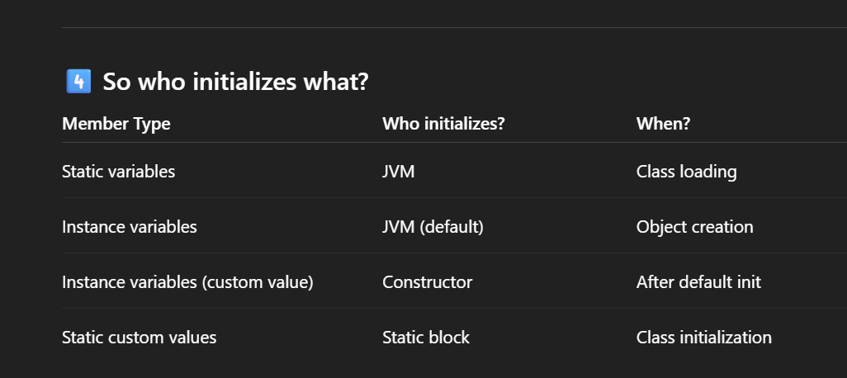
When to use this keyword
To differentiate between local and instance variables / non static variables when the variable names are same then we use this keyword.

